Lab 8: Lesson 10-2: Numeric Data Types

Exercise 1:

#include <iostream>
#include <climits>

using namespace std;

int main()
{
cout << "Here is INT_MAX \t" << INT_MAX << ": " << endl
<< "Here is 1 + INT_MAX \t" << 1 + INT_MAX << ": " <<endl
<< "Here is 1 + (- INT_MAX) " << 1 + (- INT_MAX) << ": " <<endl
<< "Here is 1 -INT_MAX \t" << 1 - INT_MAX << ": " << endl
<< "Here is 1- (-INT_MAX)) \t" << 1 - (- INT_MAX) << ": " << endl;

cout << "Also, here is INT_MIN \t" << INT_MIN << ": " << endl;

system("PAUSE");
return 0;
}
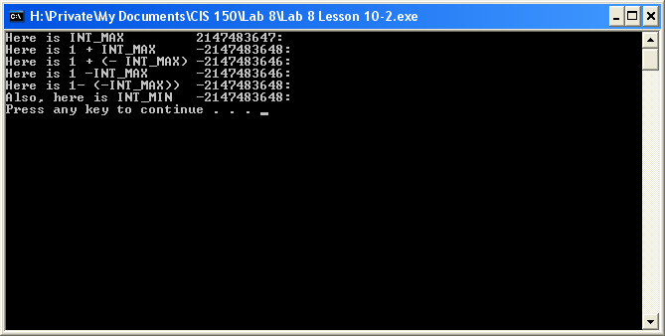
The overflow numbers are 1+ INT_MAX: -2147483648 and 1-(-INT_MAX):
-2147483648. The correct numbers are INT_MAX: 2147483647; 1 +(-INT_MAX) and
1 –INT_MAX both are -2147483646.

Exercise 3:

// Program Problems demonstrates some problems associated
// with real arithmetic.

#include <iostream>
#include <iomanip>
using namespace std;

int main ()
{
float oneThird;
float one;
cout.setf(ios::fixed, ios::floatfield);
cout.setf(ios::showpoint);

oneThird = 1.0 / 3.0;
cout << " 1/3 " << setprecision(5) << setw(7)
<< oneThird << endl;
one = oneThird + oneThird + oneThird;
cout << " 1/3 + 1/3 + 1/3 " << setw(7)
<< one << endl;
if (one == 1.0)
cout << "Result when used in test is 1.0."
<< endl;
else
cout << "Result when used in test is NOT 1.0."
<< endl;

system("PAUSE");
return 0;
}
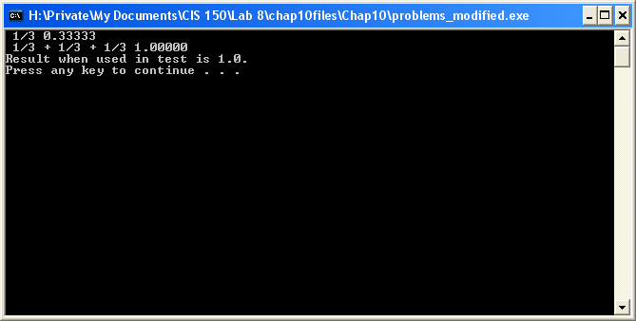

This tells me that the C++ system, due to the setprecision(5), rounded the value so the variable ‘one’ was equal to 1.0.

Exercise 4:

// Program Problems demonstrates some problems associated
// with real arithmetic.

#include <iostream>
#include <iomanip>
using namespace std;

int main ()
{
float oneTenth;
float one;
cout.setf(ios::fixed, ios::floatfield);
cout.setf(ios::showpoint);

oneTenth = 1.0 / 10.0;
cout << " 1/10 " << setprecision(5) << setw(7)
<< oneTenth << endl;
one = oneTenth + oneTenth + oneTenth + oneTenth + oneTenth + oneTenth + oneTenth + oneTenth + oneTenth + oneTenth;
cout << " 1/10 (10 times) " << setw(7)
<< one << endl;
if (one == 1.0)
cout << "Result when used in test is 1.0."
<< endl;
else
cout << "Result when used in test is NOT 1.0."
<< endl;

system("PAUSE");
return 0;
}
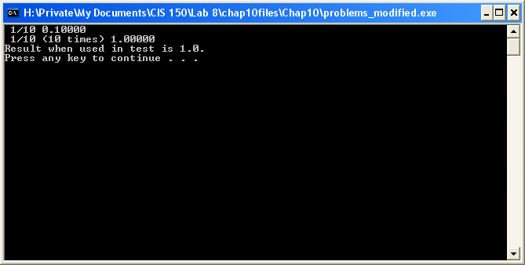

It is true that 1.0/10.0 added ten times will result in the value of 1.00000. It is equivalent to, but not exactly the same as 1.0, as it is more precise. Setprecision(5) does not cause anything to “round” up.

